SIMATS ENGINEERING
ASSESSMENT TOOL 1: Experiments
COURSE NAME: COMPUTER VISION COURSE CODE:ITA-0515
Slot : B

COURSE OUTCOME COVERED

CO3: Analyze and extract image features using detection and matching techniques for effective image representation and comparison. (BTL 4)

Assessment Tool Weightage: 40%

QUESTIONS:3 Total Marks 30 Duration :60 Minutes

Annexure A
Experiments

Code of Conduct:
I, S Durga Prasad/192472091 (Name / Reg No) certify that this submission is my original work and that I have adhered to the guidelines specified for this assessment.
I understand that any violation of academic integrity rules will result in disciplinary action.
Signature of the student:
S Durga Prasad

Rubrics for Evaluation :
Criteria | Weightage (%) | Level 4 (Exemplary) | Level 3 (Proficient) | Level 2 (Developing) | Level 1 (Beginning) | Marks(100)
Understanding of Concepts | 25 | Demonstrates thorough understanding and effectively integrates multiple concepts/technologies | Good understanding with proper integration of most concepts | Basic understanding; limited or partial integration | Poor understanding; unable to integrate concepts
Experimental Design | 30 | Well-planned, systematic implementation with optimal solution | Correct implementation with minor issues | Basic implementation with errors or inefficiencies | Incorrect or incomplete implementation
Use of Tools | 20 | Effective and advanced use of tools/technologies with proper configuration | Appropriate use of tools with correct execution | Limited or inconsistent use of tools | Incorrect or minimal use of tools
Analysis of Results | 15 | Insightful analysis with accurate interpretation and validation of results | Good analysis with reasonable interpretation | Basic analysis with limited insights | Poor or incorrect analysis of results
Documentation | 10 | Clear, well-structured documentation with diagrams, code, and results | Organized documentation with necessary details | Basic documentation with missing details | Poor or incomplete documentation

1. Harris Corner Detection Analysis
Perform Harris corner detection on images containing varying textures and patterns. Explain the concept of corner detection and its importance in computer vision tasks. Use appropriate parameters and tools to execute the experiment, document the detected corner points clearly, and analyze the distribution, accuracy, and significance of the detected corners.

Answer :
Code
import cv2
import numpy as np
import matplotlib.pyplot as plt
from tkinter import Tk, filedialog
# Open file selection window
root = Tk()
root.withdraw()
file_path = filedialog.askopenfilename(
title="Select an Image",
filetypes=[
("Image Files", "*.jpg *.jpeg *.png *.bmp")
]
)
# Read selected image
image = cv2.imread(file_path)
# Check if image is loaded
if image is None:
print("Error: Image not found or not selected.")
exit()
# Convert BGR to RGB
image_rgb = cv2.cvtColor(image, cv2.COLOR_BGR2RGB)
# Convert image to grayscale
gray = cv2.cvtColor(image, cv2.COLOR_BGR2GRAY)
# Convert grayscale image to float32
gray = np.float32(gray)
# Harris Corner Detection
dst = cv2.cornerHarris(
gray,
blockSize=2,
ksize=3,
k=0.04
)
# Dilate the result to make corners more visible
dst = cv2.dilate(dst, None)
# Set threshold
threshold = 0.01 * dst.max()
# Create a copy of original image
result = image_rgb.copy()
# Mark detected corners in red
result[dst > threshold] = [255, 0, 0]
# Count detected corners
corner_count = np.sum(dst > threshold)
# Display original and detected images
plt.figure(figsize=(12, 5))
plt.subplot(1, 2, 1)
plt.imshow(image_rgb)
plt.title("Original Image")
plt.axis("off")
plt.subplot(1, 2, 2)
plt.imshow(result)
plt.title("Harris Corner Detection")
plt.axis("off")
plt.tight_layout()
plt.show()
# Display number of detected corners
print("Number of detected corners:", corner_count)

Input & Output :
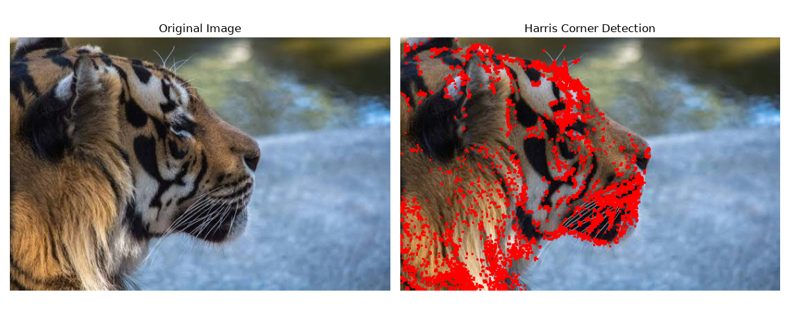
Objective
- To understand the concept of corner detection.
- To implement the Harris Corner Detection algorithm using OpenCV.
- To detect corners in images with different textures and patterns.
- To analyze the distribution and quality of detected corners.
- To understand the importance of corners in computer vision applications.

Theory
What is Corner Detection?
A corner is a point in an image where the intensity changes significantly in two different directions.
For example:
- A flat region → very little intensity change.
- An edge → intensity changes mainly in one direction.
- A corner → intensity changes significantly in two directions.
Corners contain important structural information about an image, making them useful features for computer vision algorithms.
Example
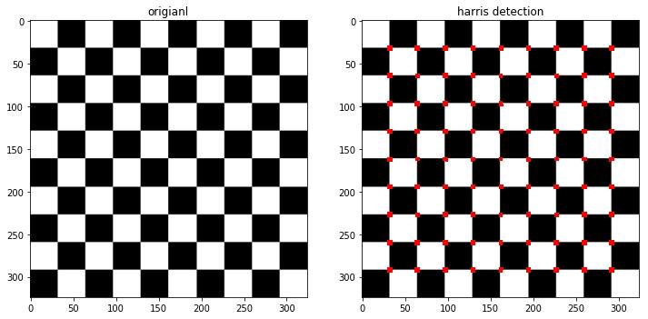
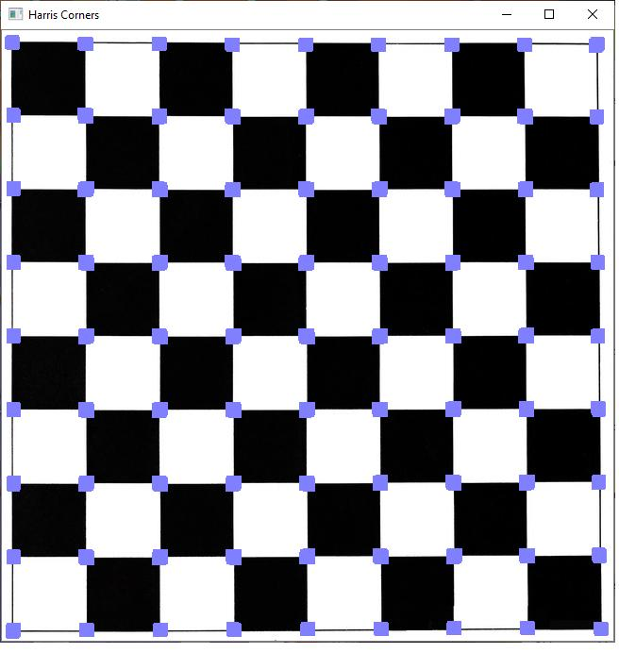
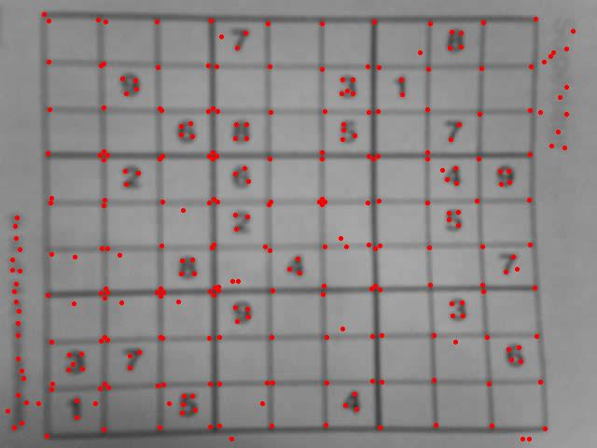
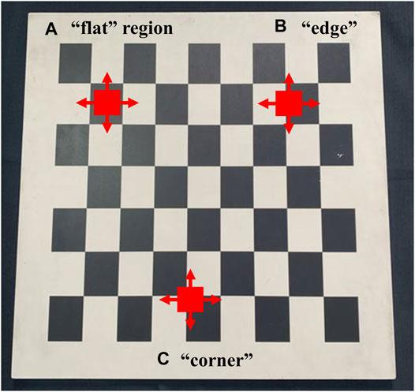

Importance of Corner Detection
Corner detection is an important feature extraction technique used in computer vision.
It is commonly used in:
- Object recognition
- Image matching
- Image stitching
- Motion tracking
- Optical flow
- 3D reconstruction
- Robot navigation
- Panorama generation
- Augmented reality
- Feature-based image registration
Corners are generally more distinctive than flat regions because their surrounding intensity pattern provides useful information for identifying the same point in another image.

Algorithm
Step 1
Read the input image.
Step 2
Convert the image into grayscale.
Step 3
Convert the grayscale image to floating-point format.
Step 4
Apply the Harris Corner Detection algorithm.
Step 5
Calculate the corner response (R).
Step 6
Apply a threshold to identify strong corners.
Step 7
Mark the detected corners on the original image.
Step 8
Display and analyze the resulting image.

Experiments with Different Images
Image 1 – Simple geometric pattern
Example:
Chessboard / geometric shapes
Expected result:
- Large number of clearly defined corners.
- Corners are concentrated at intersections of lines.
- Detection accuracy is generally high.
Image 2 – Natural scene
Example:
Building / road / trees
Expected result:
- Corners occur around windows, building edges, objects, etc.
- Some regions may have fewer detectable corners.
- Texture affects the number of detected points.
Image 3 – Highly textured image
Example:
Brick wall / fabric / leaves
Expected result:
- Many corner points may be detected.
- Corners are distributed throughout textured regions.
- Some detected points may be less visually significant.
Observation Table
Image | Texture | Expected Corner Distribution | Detection Quality
Chessboard | Regular | Highly concentrated at intersections | Very High
Building | Moderate | Around windows, edges and object boundaries | High
Brick wall | High | Distributed throughout texture | Moderate–High
Plain wall | Low | Very few corners | Low
Natural scene | Variable | Distributed around object structures | Moderate

Analysis
1. Distribution of Corners
The detected corners are not uniformly distributed.
They tend to occur at locations where there are strong intensity changes in two directions, such as:
- Line intersections
- Object boundaries
- Shape junctions
- Texture patterns
- Geometric structures
2. Accuracy
The accuracy of Harris detection depends on:
- Image quality
- Noise
- Texture
- Threshold value
- Block size
- Sobel kernel size
- Harris constant (k)
A suitable threshold is important because a very low threshold can result in many false detections.

Effect of Threshold
You can perform an additional analysis by changing the threshold.
Threshold | Number of Corners | Observation
0.005 × max | High | Many weak corners detected
0.01 × max | Moderate | Balanced detection
0.05 × max | Low | Only strong corners detected
0.10 × max | Very Low | Only very strong corners remain

Therefore, 0.01 × maximum response can be used as a reasonable starting value, but the optimal value depends on the image.

Result
The Harris Corner Detection algorithm successfully detects significant corner points in images containing different textures and patterns.
The experiment demonstrates that:
- Geometric images produce clearly identifiable corners.
- Highly textured images produce a larger number of detected points.
- Smooth regions produce few or no corners.
- Threshold selection strongly influences the number of detected corners.
- Strong corners provide useful features for subsequent computer vision tasks.
Conclusion
Harris Corner Detection is an effective feature detection technique for identifying points where significant intensity changes occur in two directions. The experiment shows that the distribution and number of detected corners depend strongly on the image texture, pattern, and algorithm parameters.
The detected corner points can serve as important features for applications such as image matching, object recognition, image stitching, motion tracking, and 3D reconstruction. Proper selection of parameters such as block size, Sobel kernel size, Harris constant, and threshold is essential for obtaining reliable corner detection results.

2. Effect of Noise on Corner Detection
Design an experiment to study the effect of noise on Harris corner detection performance. Explain the purpose of introducing noise and its influence on image features. Add noise systematically, perform corner detection using suitable tools, document observations for original and noisy images, and analyze the impact of noise along with possible improvement techniques.
Answer :
Code :
import cv2
import numpy as np
import matplotlib.pyplot as plt
from tkinter import Tk, filedialog
# -----------------------------------
# Select Image
# -----------------------------------
root = Tk()
root.withdraw()
file_path = filedialog.askopenfilename(
title="Select an Image",
filetypes=[
("Image Files", "*.jpg *.jpeg *.png *.bmp")
]
)
# Read image
image = cv2.imread(file_path)

if image is None:
print("Error: Image not found or not selected.")
exit()
# -----------------------------------
# Function for Harris Corner Detection
# -----------------------------------
def detect_corners(image):
# Convert to grayscale
gray = cv2.cvtColor(image, cv2.COLOR_BGR2GRAY)
# Convert to float32
gray = np.float32(gray)
# Harris Corner Detection
dst = cv2.cornerHarris(
gray,
blockSize=2,
ksize=3,
k=0.04
)
# Dilate corners
dst = cv2.dilate(dst, None)
# Threshold
threshold = 0.01 * dst.max()
# Copy image
result = cv2.cvtColor(image, cv2.COLOR_BGR2RGB)
# Mark corners in red
result[dst > threshold] = [255, 0, 0]
# Count corners
corner_count = np.sum(dst > threshold)
return result, corner_count
# -----------------------------------
# Function to Add Gaussian Noise
# -----------------------------------
def add_gaussian_noise(image, sigma):
# Generate Gaussian noise
noise = np.random.normal(
0,
sigma,
image.shape
)
# Add noise
noisy_image = image.astype(np.float32) + noise
# Keep pixel values between 0 and 255
noisy_image = np.clip(
noisy_image,
0,
255
)
# Convert back to uint8
noisy_image = noisy_image.astype(np.uint8)
return noisy_image
# -----------------------------------
# Noise Levels
# -----------------------------------
noise_levels = [0, 10, 25, 50]
results = []
corner_counts = []

# -----------------------------------
# Process Each Noise Level
# -----------------------------------
for sigma in noise_levels:
if sigma == 0:
noisy_image = image.copy()
else:
noisy_image = add_gaussian_noise(
image,
sigma
)
# Detect corners
result, count = detect_corners(
noisy_image
)
results.append(result)
corner_counts.append(count)

# -----------------------------------
# Display Results
# -----------------------------------
plt.figure(figsize=(12, 10))
for i in range(len(noise_levels)):
plt.subplot(2, 2, i + 1)
plt.imshow(results[i])
plt.title(
"Noise = " +
str(noise_levels[i]) +
"\nCorners = " +
str(corner_counts[i])
)
plt.axis("off")
plt.tight_layout()
plt.show()
# -----------------------------------
# Print Results
# -----------------------------------
print("\nHARRIS CORNER DETECTION RESULTS")
print("--------------------------------")
for i in range(len(noise_levels)):
print(
"Noise Level:",
noise_levels[i],
"| Detected Corners:",
corner_counts[i]
)

Input & Output :
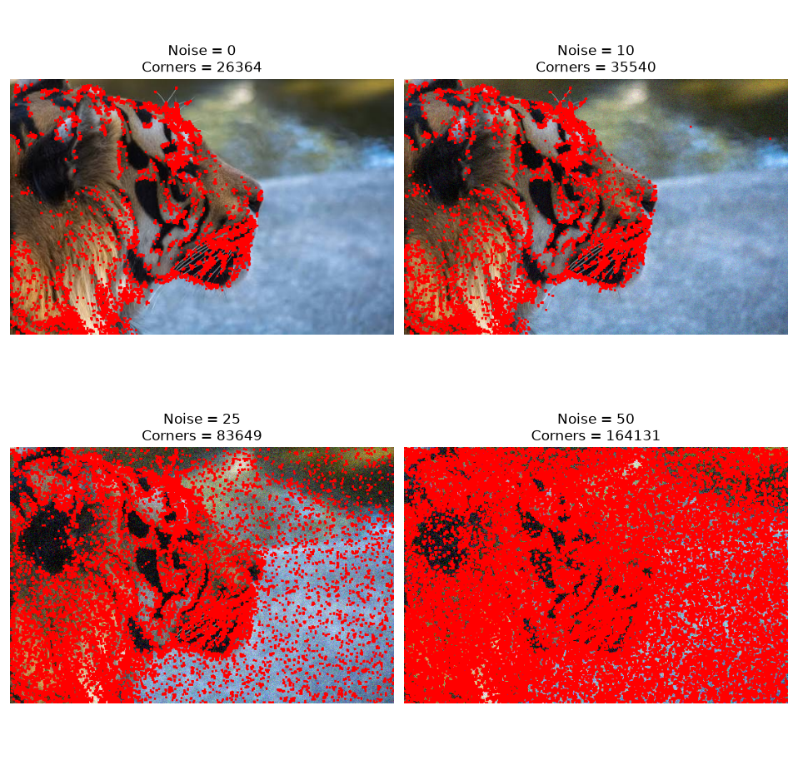

Objective
- To understand the effect of noise on image features.
- To introduce noise systematically into an image.
- To apply Harris Corner Detection to both original and noisy images.
- To compare the number and distribution of detected corners.
- To study techniques that can improve corner detection in noisy images.
Theory
What is Noise?
Noise is unwanted random variation in the intensity or color of pixels in an image.
Noise can be introduced during:
- Image acquisition
- Camera sensors
- Low-light photography
- Image transmission
- Compression
- Electronic interference
Noise can create artificial intensity changes that may be incorrectly interpreted as image features.

Why Introduce Noise?
In a real-world computer vision system, images are rarely perfect.
For example, a camera operating in low light may produce a noisy image:
Original:

███████
███████
███████

Noisy:

█▓███▓█
██▓████
████▓██
The random intensity variations can produce additional gradients.
Since Harris Corner Detection relies on intensity changes in two directions, noise can result in:
- False corners
- Missed corners
- Incorrect corner locations
- Increased number of detected corners
- Reduced detection reliability
Therefore, studying noise is important for evaluating the robustness of a corner detection algorithm.
Noise Levels:
Noise Level | Standard Deviation | Description
Original | 0 | No noise
Low | 10 | Slight noise
Medium | 25 | Moderate noise
High | 50 | Strong noise

This allows us to observe how Harris corner detection changes as noise increases.

Algorithm
Step 1
Select and read an input image.
Step 2
Convert the image to grayscale.
Step 3
Apply Harris Corner Detection to the original image.
Step 4
Generate Gaussian noise with different standard deviations.
Step 5
Add the noise to the original image.
Step 6
Apply Harris Corner Detection to each noisy image.
Step 7
Count the detected corners.
Step 8
Display the original and noisy images with their detected corners.
Step 9
Compare the results and analyze the effect of noise.

Analysis
Original Image
In the original image, Harris detects corners mainly at meaningful structural locations such as:
- Object boundaries
- Intersections
- Shape edges
- Texture patterns
The detected corners are relatively stable.

Low Noise
When a small amount of Gaussian noise is introduced, small random intensity variations appear.
These variations can produce additional gradients.
Therefore, some false corners may be detected.

Medium Noise
As the noise increases, more random intensity changes occur.
Harris may interpret these changes as genuine image features.
Consequently:
- Number of detected corners increases.
- False positive corners increase.
- Corner distribution becomes less meaningful.
- Detection accuracy decreases.

High Noise
At high noise levels, the image contains many random intensity variations.
This can cause Harris to detect a large number of false corners.
The detected points may no longer correspond to meaningful structures in the original image.
Therefore, the reliability of corner detection decreases significantly.

Effect of Noise on Harris Corner Detection
The relationship can be summarized as:
Noise increases
↓
Random pixel variations increase
↓
Image gradients increase
↓
More false corner responses
↓
Corner detection becomes less reliable
Thus, noise generally reduces the reliability of Harris Corner Detection.
Comparison
Parameter | Original | Low Noise | Medium Noise | High Noise
Image quality | High | Slightly reduced | Reduced | Very low
False corners | Very low | Low | Moderate | High
Corner distribution | Meaningful | Mostly meaningful | Less meaningful | Highly scattered
Detection reliability | High | High–moderate | Moderate | Low
Need for preprocessing | Low | Low | Recommended | Highly recommended

Result
The experiment demonstrates that increasing Gaussian noise affects the performance of Harris Corner Detection.
At low noise levels, the effect is relatively small. As noise increases, random intensity variations produce additional corner responses, resulting in false-positive corners and reduced detection reliability.

Conclusion
The experiment successfully demonstrates the effect of noise on Harris Corner Detection. Noise introduces unwanted intensity variations that can be interpreted as image features, causing false corner detections and reducing the accuracy of the detector.
The performance can be improved by applying Gaussian or median filtering before corner detection, increasing the detection threshold, and using appropriate preprocessing techniques. Therefore, noise reduction is an important preprocessing step for reliable corner detection in real-world computer vision applications.

3. Hough Transform for Shape Detection
Conduct an experiment using the Hough Transform to detect lines or circles in an image. Explain the principles and significance of the Hough Transform in shape detection. Execute the detection process using appropriate tools, record the detected shapes and their parameters, and analyze the detection accuracy under different image conditions.
Answer :

Objectives
- To understand the principle of the Hough Transform.
- To detect straight lines in an image.
- To detect circular shapes in an image.
- To study the important parameters of the Hough Transform.
- To analyze the effect of image quality and noise on shape detection.
- To evaluate the accuracy and significance of the detected shapes.
Theory
What is Hough Transform?
The Hough Transform is a feature extraction technique used to detect specific geometric shapes in an image.
It is commonly used to detect:
- Straight lines
- Circles
- Ellipses
- Other parametric shapes
The major advantage of the Hough Transform is that it can detect shapes even when the edges are broken, incomplete, or affected by noise.
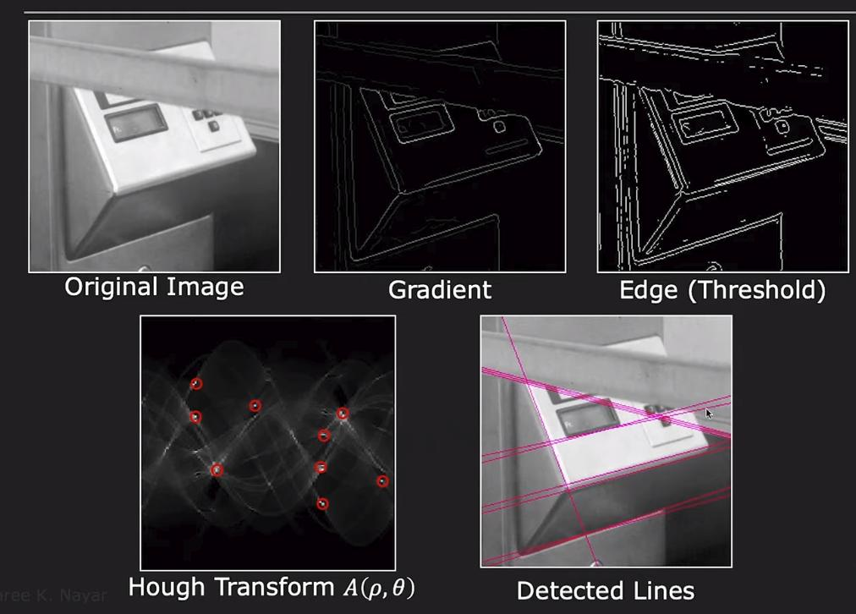
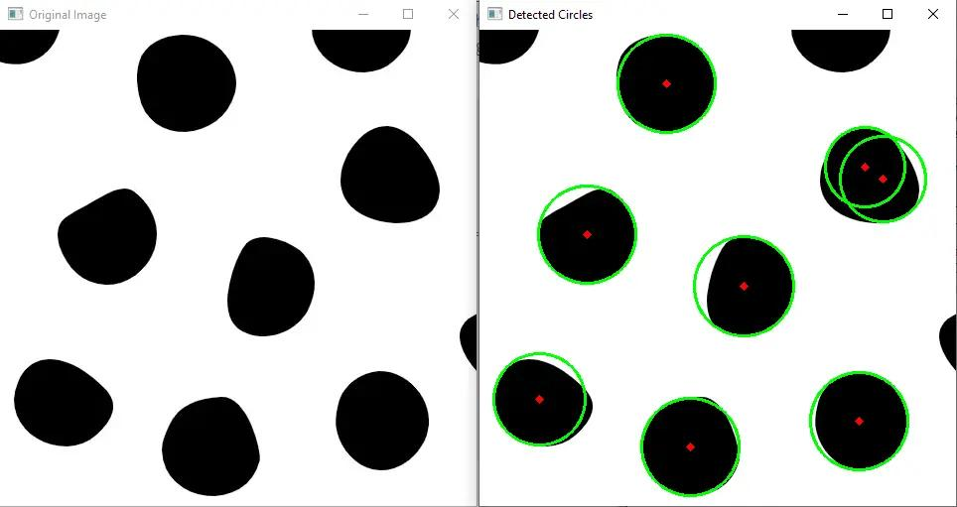
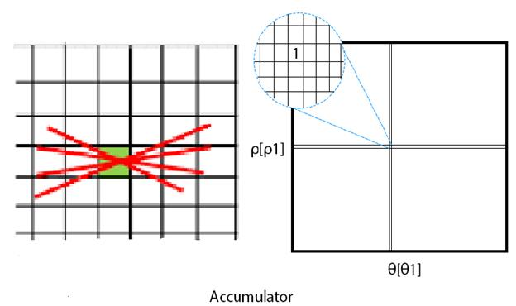
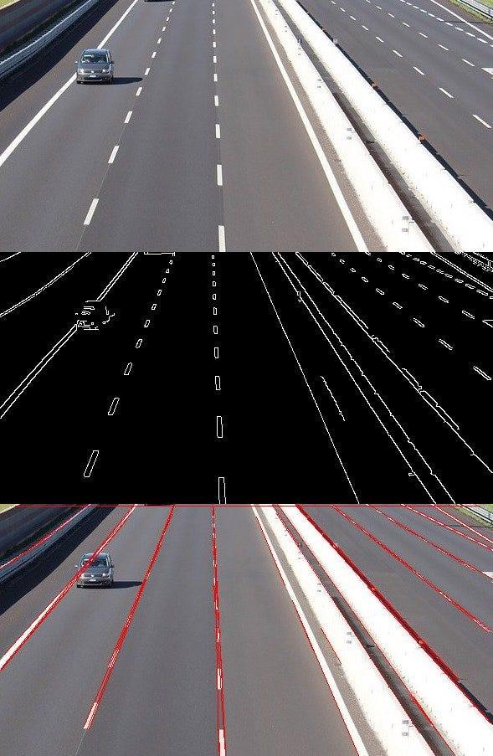
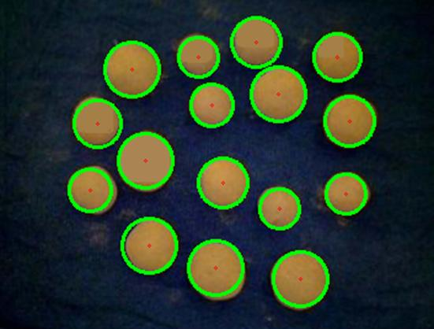
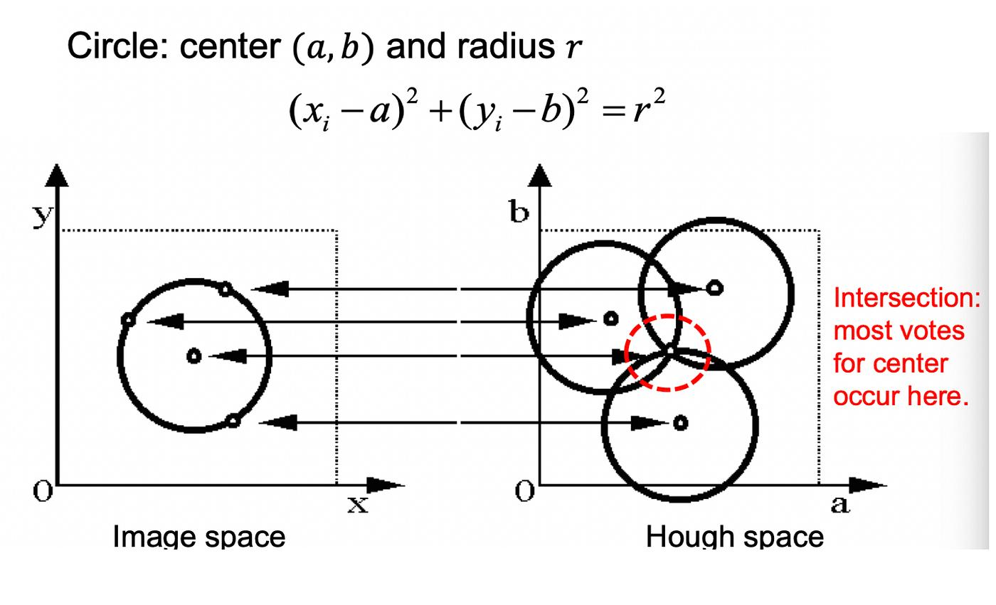
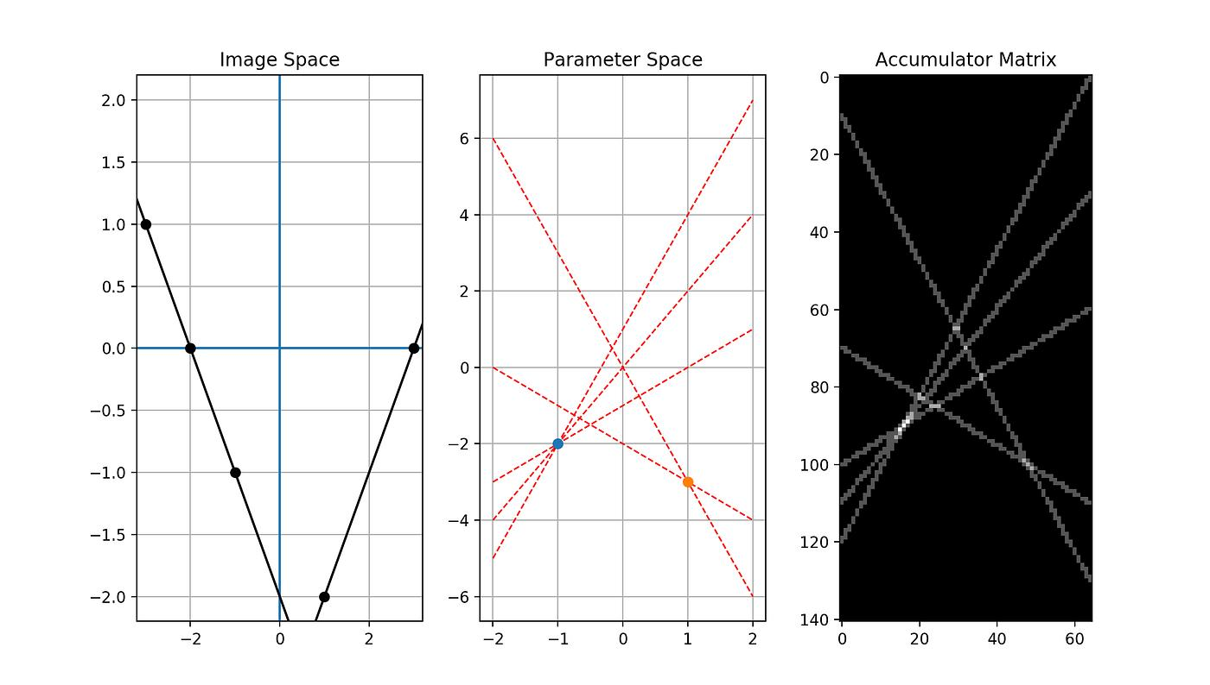
Principle of Hough Transform
The Hough Transform converts the problem of detecting shapes in image space into finding points in a parameter space.
Each edge point in the image votes for possible lines.
The line receiving a sufficiently large number of votes is considered a detected line.

Importance of Hough Transform
The Hough Transform is important because it can detect geometric structures even when the image is not perfect.
Applications include:
- Road lane detection
- Traffic sign detection
- Industrial inspection
- Object detection
- Medical image analysis
- Document analysis
- Shape recognition
- Robot vision
- Automatic measurement
- Computer-aided manufacturing

Straight Line Detection
For line detection, we use the Probabilistic Hough Line Transform:
cv2.HoughLinesP()
This method returns the endpoints of detected line segments.

Algorithm for Line Detection
Step 1
Read the input image.
Step 2
Convert the image to grayscale.
Step 3
Apply Gaussian blur to reduce noise.
Step 4
Apply Canny edge detection.
Step 5
Apply the Hough Line Transform.
Step 6
Draw the detected lines on the original image.
Step 7
Count and analyze the detected lines.

Hough Line Detection
import cv2
import numpy as np
import matplotlib.pyplot as plt
from tkinter import Tk, filedialog

# ---------------------------------------
# Select Image
# ---------------------------------------

root = Tk()
root.withdraw()

file_path = filedialog.askopenfilename(
title="Select an Image",
filetypes=[
("Image Files", "*.jpg *.jpeg *.png *.bmp")
]
)

# Read image
image = cv2.imread(file_path)

if image is None:
print("Error: Image not found or not selected.")
exit()

# ---------------------------------------
# Convert to Grayscale
# ---------------------------------------

gray = cv2.cvtColor(
image,
cv2.COLOR_BGR2GRAY
)

# ---------------------------------------
# Reduce Noise
# ---------------------------------------

blur = cv2.GaussianBlur(
gray,
(5, 5),
0
)

# ---------------------------------------
# Canny Edge Detection
# ---------------------------------------

edges = cv2.Canny(
blur,
50,
150
)

# ---------------------------------------
# Hough Line Transform
# ---------------------------------------

lines = cv2.HoughLinesP(
edges,
rho=1,
theta=np.pi / 180,
threshold=80,
minLineLength=50,
maxLineGap=10
)

# Convert image to RGB
result = cv2.cvtColor(
image,
cv2.COLOR_BGR2RGB
)

# ---------------------------------------
# Draw Detected Lines
# ---------------------------------------

line_count = 0

if lines is not None:

for line in lines:

x1, y1, x2, y2 = line[0]

cv2.line(
result,
(x1, y1),
(x2, y2),
(255, 0, 0),
2
)

line_count += 1

# ---------------------------------------
# Display Results
# ---------------------------------------

plt.figure(figsize=(12, 5))

plt.subplot(1, 2, 1)
plt.imshow(
cv2.cvtColor(image, cv2.COLOR_BGR2RGB)
)
plt.title("Original Image")
plt.axis("off")

plt.subplot(1, 2, 2)
plt.imshow(result)
plt.title(
"Hough Line Detection\n"
"Lines Detected: " + str(line_count)
)
plt.axis("off")

plt.tight_layout()
plt.show()

# ---------------------------------------
# Print Results
# ---------------------------------------

print("Number of detected lines:", line_count)

if lines is not None:

print("\nDetected Line Parameters:")

for i, line in enumerate(lines):

x1, y1, x2, y2 = line[0]

print(
"Line", i + 1,
": (", x1, ",", y1, ") -> (",
x2, ",", y2, ")"
)
Input & output :
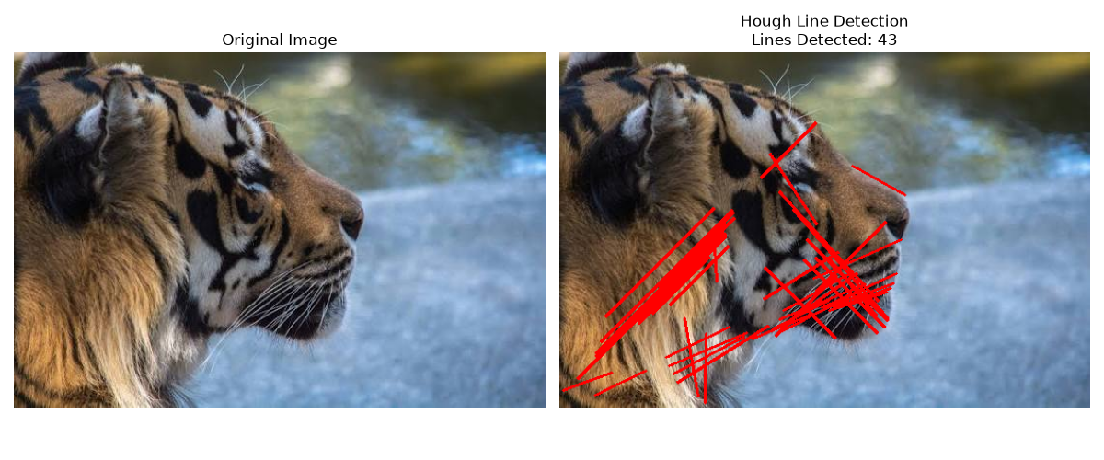

Circle Detection
OpenCV provides:
cv2.HoughCircles()
for detecting circles.
The general process is:
Input Image
↓
Grayscale
↓
Gaussian Blur
↓
Hough Circle Transform
↓
Detected Circles
↓
Draw Center + Radius

Python Program — Hough Circle Detection
import cv2
import numpy as np
import matplotlib.pyplot as plt
from tkinter import Tk, filedialog

# ---------------------------------------
# Select Image
# ---------------------------------------

root = Tk()
root.withdraw()

file_path = filedialog.askopenfilename(
title="Select an Image",
filetypes=[
("Image Files", "*.jpg *.jpeg *.png *.bmp")
]
)

# Read image
image = cv2.imread(file_path)

if image is None:
print("Error: Image not found or not selected.")
exit()

# ---------------------------------------
# Convert to Grayscale
# ---------------------------------------

gray = cv2.cvtColor(
image,
cv2.COLOR_BGR2GRAY
)

# ---------------------------------------
# Apply Gaussian Blur
# ---------------------------------------

gray = cv2.GaussianBlur(
gray,
(9, 9),
2
)

# ---------------------------------------
# Hough Circle Detection
# ---------------------------------------

circles = cv2.HoughCircles(
gray,
cv2.HOUGH_GRADIENT,
dp=1,
minDist=30,
param1=100,
param2=30,
minRadius=10,
maxRadius=200
)

# Convert image to RGB
result = cv2.cvtColor(
image,
cv2.COLOR_BGR2RGB
)

circle_count = 0

# ---------------------------------------
# Draw Detected Circles
# ---------------------------------------

if circles is not None:

circles = np.round(
circles[0, :]
).astype(int)

circle_count = len(circles)

for x, y, r in circles:

# Draw circle
cv2.circle(
result,
(x, y),
r,
(255, 0, 0),
2
)

# Draw center
cv2.circle(
result,
(x, y),
3,
(0, 255, 0),
-1
)

# ---------------------------------------
# Display Results
# ---------------------------------------

plt.figure(figsize=(12, 5))

plt.subplot(1, 2, 1)

plt.imshow(
cv2.cvtColor(image, cv2.COLOR_BGR2RGB)
)

plt.title("Original Image")
plt.axis("off")

plt.subplot(1, 2, 2)

plt.imshow(result)

plt.title(
"Hough Circle Detection\n"
"Circles Detected: " +
str(circle_count)
)

plt.axis("off")

plt.tight_layout()
plt.show()

# ---------------------------------------
# Print Circle Parameters
# ---------------------------------------

print(
"Number of detected circles:",
circle_count
)

if circles is not None:

print("\nDetected Circle Parameters:")

for i, (x, y, r) in enumerate(circles):

print(
"Circle", i + 1,
": Center = (",
x, ",", y,
"), Radius =",
r
)
Input & output :
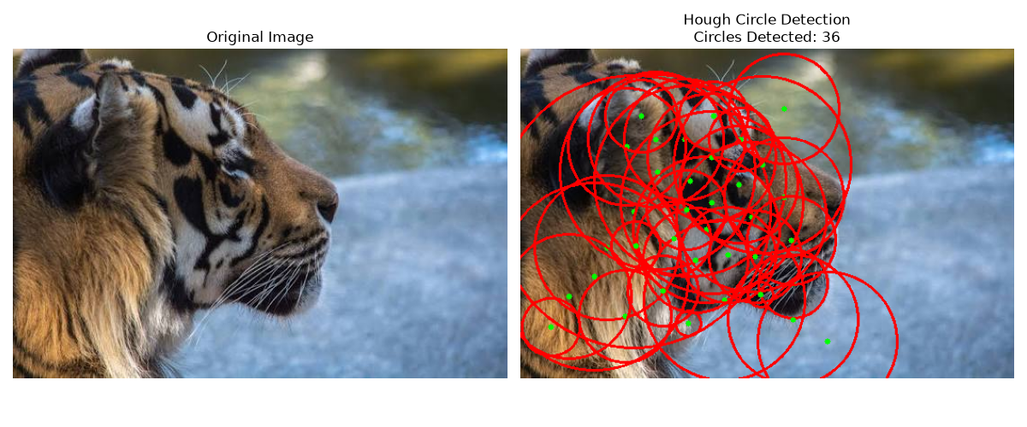
Observation Table — Line Detection
Use the actual numbers generated by your program.
Image Condition | Lines Detected | Detection Quality
Original/Clear | Record output | High
Low Noise | Record output | High–Moderate
Medium Noise | Record output | Moderate
High Noise | Record output | Low
Blurred | Record output | Moderate–Low

Observation Table — Circle Detection
Image Condition | Circles Detected | Detection Quality
Original/Clear | Record output | High
Low Noise | Record output | High–Moderate
Medium Noise | Record output | Moderate
High Noise | Record output | Low
Blurred | Record output | Moderate–Low

Analysis
Effect of Noise
Noise produces additional edges in an image. Since the Hough Transform works using edge information, these additional edges can generate unwanted votes in the accumulator.
This can result in:
- False lines
- False circles
- Incorrect parameters
- Reduced detection accuracy
Effect of Blur
Blurring removes high-frequency information.
As a result:
- Small lines may disappear.
- Small circles may not be detected.
- Strong geometric shapes may remain detectable.

Effect of Threshold
The Hough threshold controls how many votes are required to identify a shape.
A low threshold gives:
More detections
↓
More false positives
A high threshold gives:
Fewer detections
↓
Stronger detections
↓
Possible missed shapes
Therefore, the threshold should be selected carefully.
Advantages
- Can detect incomplete shapes.
- Works well for geometric shapes.
- Can tolerate some noise.
- Does not require the complete boundary of an object.
- Useful for automated shape detection.

Limitations
- Computationally expensive for complex images.
- Sensitive to parameter selection.
- Can produce false detections.
- Noise can affect the accumulator.
- High-resolution images may require more computation.
- Multiple similar shapes can make detection difficult.

Applications
Hough Transform is widely used in:
- Lane detection in autonomous vehicles
- Traffic sign recognition
- Industrial quality inspection
- Coin detection
- Medical imaging
- Road and building analysis
- Object recognition
- Robotics
- Document processing

Result
The Hough Transform was successfully used to detect straight lines and circular shapes from images. The detected shapes were represented using their corresponding geometric parameters such as line endpoints, circle center coordinates, and radius.
The experiment showed that detection performance depends strongly on image quality, noise, blur, edge strength, and Hough Transform parameters.

Conclusion
The experiment demonstrates that the Hough Transform is an effective technique for detecting geometric shapes such as lines and circles. It transforms image-space information into parameter space and identifies shapes based on accumulated votes.
Clear images produce more accurate detections, while noise and blur can reduce detection accuracy and introduce false shapes. Appropriate preprocessing, edge detection, and parameter tuning can significantly improve the performance of the Hough Transform in practical computer vision applications.

